ETHICAL HACKING
A project report submitted
For
INFORMATION TECHNOLOGY
By
NAVAL VISHWAKARMA

Under the guidance of

MR. PRAVEEN KUMAR JOSHI

EVER GREEN SENIOR SECONDARY SCHOOL
(governed by educational welfare society)
Tularampur distt NAINITAL, UTTARAKHAND

CERTIFICATE

This certificate is certified that the project ETHICAL HACKING being submitted to evergreen senior secondary school, Haldwani for the project work of INFORMATION AND TECHNOLOGY is the record of the work carried by MR PRAVEEN KUMAR JOSHI
Under my guidance and supervision

Supervisor.
MR PRAVEEN JOSHI
(TGT COMPUTER)
Ever green senior secondary school

ACKNOWLEDGMENT

I would like to express my special thanks of gratitude to my teacher Mr Praveen Joshi who gave me the golden opportunity to do this wonderful project on the topic ETHICAL HACKING which also helped me in doing a lot of Research and I came to know about so many new things I am really thankful to them.
Secondly I would also like to thank my parents and friends who helped me a lot in finalizing this project within the limited time frame.

INTRODUCTION
- ETHICAL HACKING

Ethical hacking also known as penetration testing or pen testing is legally breaking into computer and device to test the organisation defence it’s among that most exciting jobs provide to any person can be involved in you are literally getting paid to keep up with the latest technology an get to break into computer without threat of being arrested you hired as a legal hacker


ETHICAL HACKER

Companies engage ethical hackers to identify Werner abilities in their systems from the penetration tester point of view there is no downside if you hack in past the current defence you have given the client a chance to close the
hole before an attacker discovered if you don't find anything your client is even happier becausr they are now get declare their system is secure enough that even paid hackers
there are high level jobs for ethical hackers in mnc’s and big IT giants Because ethical hackers can predict where the loopholes before it caught by a real hacker

TEAM OF ETHICAL HACKERS

- importance of ethical hacking

Ethical hacking is used to secure important data off any Bank or any From the hackers it also used to prevent cyber terrorism attacks the ethical hacker stop many cyber attacks like Bank robbery by hackers.

Ethical hacking help us to learn new skills used in many roles like software developing, risk management, quality assurance tester and network defender in an organisation ethical hacking can identify the weakness of your software security using the hacker perspective you can look at your security and fix any off disabilities of your software before making a problem in the company
success

The primary benefit of ethical hacking is to prevent data from being stolen and misused by malicious attackers, as well as: Discovering vulnerabilities from an attacker’s POV so that weak points can be fixed. Implementing a secure network that prevents security breaches.

- TYPES OF HACKERS

- White Hat Hackers.
- Black Hat Hackers.
- Gray Hat Hackers.
- Script Kiddies.
- Green Hat Hackers.
- Blue Hat Hackers.
- Red Hat Hackers.
- State/Nation Sponsored Hackers.
- Hacktivist

- USE OF ETHICAL HACKING
It is very useful to the generation emerging from engineering and there is need of more other branches for ethical hacking is one of them different companies are looking for cyber security provider for them companies they pay a lot for this

Not only it is beneficial for yourself as well as others it is good to stop the cyber crimes that are occurring day by day an increasing in numbers hence these are the uses of ethical hacking

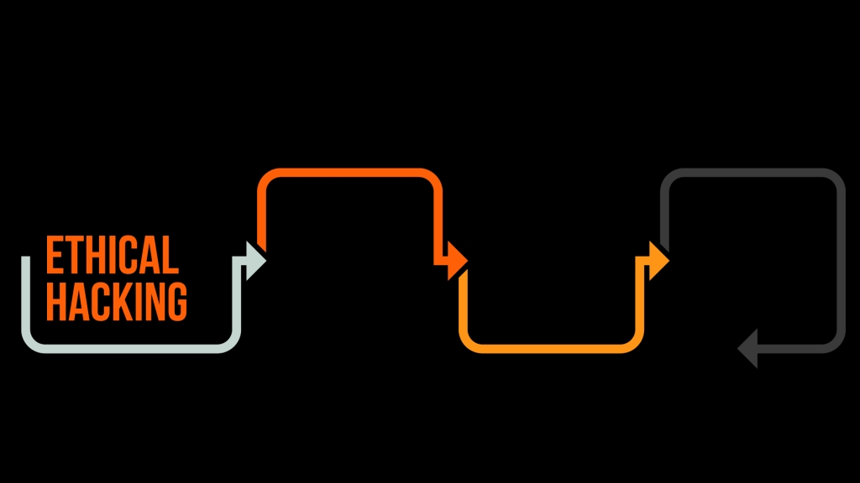

- CAREER OPPORTUNITIES IN ETHICAL HACKING

- Government/private firm’s
With increasing cyber threats government and private organisation are in search of ethical hackers who can help organisation to protect themselves from the threat or attacks in the cyber programmes.

- Own business
You can start your own business as a ethical hacker by becoming a freelancer and starting a freelance corporation who provide Their service by getting paid by the government and private companies there is a huge scope in this becausr freelancer are more suitable then hiring hackers for job

- Network security Engineers
a network security engineer is responsible for implementation and intregration to corporate WAN ,LAN and sever
They also look for security network hardware and software

- Network security administration
in addition to writing network security policies the security administrator Does the frequently credits and ensure the security policies are up to date and are being followed in addition he/she take corrective steps for breaches there's a huge scope for ethical hacker in this department also

- Security counsultant
Security consultants access existing IT system and infrastructure for a weakness and then develop an implement IT security solution to prevent in authorised access and modification or data loss there is a huge scope for ethical hackers in this department

- Penetretion tester
Penetration testers try to break into or find possible exploits in different computer systems and software they are generally run a number of list based around network penetration

